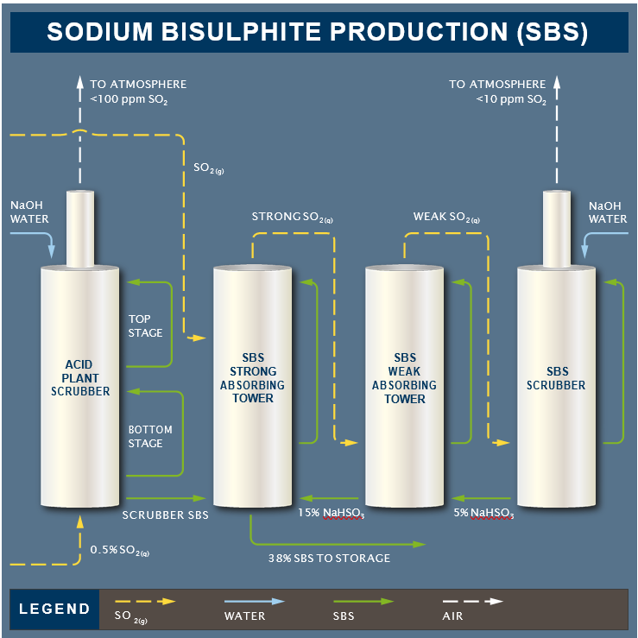
Sodium Bisulphite is manufactured from a slip stream of sulphur dioxide gas from the sulphuric acid plant which is reacted with sodium hydroxide (caustic soda) solution. The key reactions are as follows:

SO2 + 2NaOH → Na2SO3 + H2O
(sodium sulphite)

Na2SO3 + SO2 + H2O → 2NaHSO3
(sodium bisulphite)

Na2SO3 + 0.5O2 → Na2SO4
(sodium sulphate side reaction, not desirable)

SO3 + 2NaOH → Na2SO4 + H2O
(sodium sulphate side reaction, not desirable)

