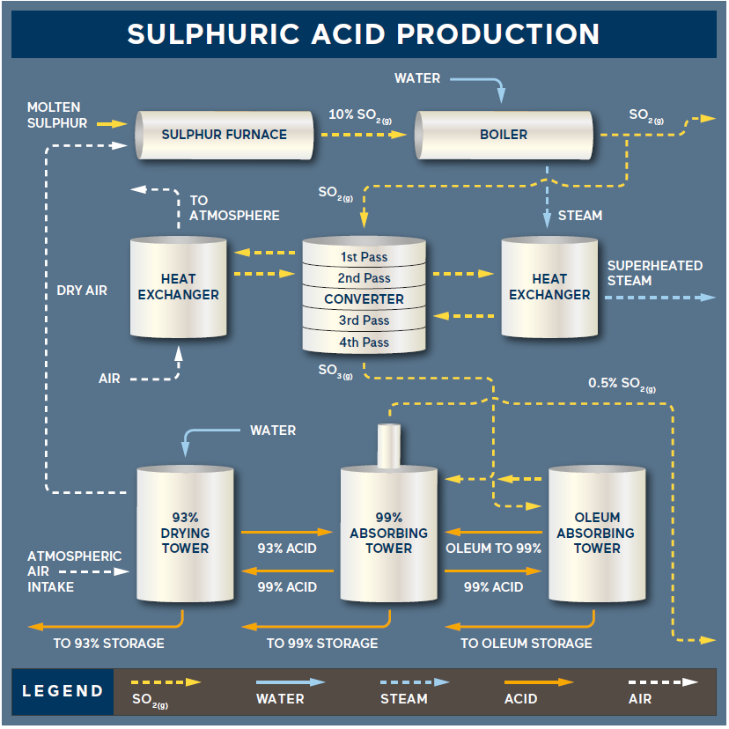
Sulphuric acid production, at CCC Sulphur Products, requires three raw materials, sulphur, air, and water.
Molten sulphur, recovered from oil refineries, is shipped via tank truck where it is unloaded into our underground storage pits. The temperature in the pits is maintained at 280°F with steam coils to maintain the liquid state of the sulphur.

The molten sulphur is pumped to the furnace via a vertical pump where it ignites with dry atmospheric air to form gaseous sulphur dioxide(SO2(g)):
S(l) + O2(g) = SO2

Drawing in atmospheric air through 93% sulphuric acid produces dry air, supplied by the blower. Sulphuric acid is very hygroscopic and readily absorbs any moisture from the air. The formation of sulphur dioxide is an exothermic reaction, meaning that heat is released during the reaction.
Temperatures in the furnace can reach 2000oF (1010oC) at a pressure of 1 psi.
The hot SO2(g) from the furnace passes through a fire tube waste heat boiler where the gas temperature is reduced to about 800oF (425oC). Water on the shell side of the boiler is in turn boiled to produce steam, which is used elsewhere in the plant for heat.

The SO2(g) from the boiler enters the converter for conversion to sulphur trioxide (SO3(g)) as shown below: V₂O₅(cat)
SO2(g) + 1/2 O2 = SO3(g)

The reaction of SO2(g) with residual oxygen (O2) from the furnace requires the aid of a catalyst. The vanadium pentoxide (V₂O5) based catalyst promotes the reaction but is not consumed at all. The reaction is again exothermic and requires interstage cooling. Four passes are required to convert approximately 99.5% of the SO2 to SO3. Stack gas emissions are continually monitored to confirm the conversion efficiency.
Exiting the converter, the SO3 gas, enters the economizer where the temperature is further reduced to approximately 400oF (200oC). This temperature reduction is accomplished by passing the gases over the economizer tubes containing boiler feedwater.

The SO3 gas, now reduced in temperature, is fed into the oleum and 99 absorbing towers. Absorption of the SO3 gas takes place quite readily. Oleum (fuming sulphuric acid) absorbs the SO3 gas and is diluted using 99% sulphuric acid to maintain the proper acid strength.

SO3(g) + H2O(l) = H2SO4 (Sulphuric Acid) SO3(g) + H2SO4 = H2SO4 ·∙ SO3 (Oleum)
Absorption of SO3 in the 99 tower combines with the water in the acid to form sulphuric acid. The resulting acid is diluted with water to maintain the acid strength. 99% acid is ultimately diluted to 93% acid for storage. Split streams of both oleum and 93% acid are transferred to storage tanks.

As a result of SO3 absorption and dilution with 99% acid/water heat is evolved in all the absorbing towers. Temperatures are maintained in the towers by circulating the acids through their respective coolers. Recirculating cooling water provides the means of cooling. The cooling water in turn is cooled through the cooling tower, which relies on evaporation of a portion of the cooling water.

